

CSE 1320 Project Documentation

AIRPLANE RESERVATION

Students names, surnames, IDs:

Aditi Hande (1002177674)

2. Sathwik Pareedula (1002142023)

3. Ved Dharmatti ( 1002148623)

4.

Mentor: MARIKA APOSTOLOVA
TA:

PROJECT LOGO


Intermediate programming CSE 1320
Student declaration:

We declare that:
- We understand what is meant by plagiarism
- The implication of plagiarism has been explained to me by our professor
- This assignment is all team own work and we have acknowledged any use of the published and unpublished works of other people.
1 Student name, surname, ID and signature: Aditi Hande (1002177674)
2 Student name, surname, ID and signature: Sathwik Pareedula (1002142023)
3 Student name, surname, ID and signature: Ved Dharmatti
4 Student name, surname, ID and signature: Jaden ?? (Still there?)

Date: 04/21/2024.

 | Total number of pages including this cover page | #39
Class Code / Group | CSE 1320/004
Lecturer’s Name | MARIKA APOSTOLOVA

Table of Contents

CHAPTER ONE
Project introduction
Current systems (Literature review)
Project Specification/ Function Modules
Project (Input/ Output) Specification
Screen Design

CHAPTER TWO
DESIGN and CODES
Module Menu Screen
Module Select
Module Add
…………………

CHAPTER THREE (optional)
PROGRAM TESTING
TEST LOG
TEST CASE

CHAPTER FOUR
CONCLUSION
Project Weakness
Project Strength
Project Enhancement
Reference
Appendix

Project Introduction

Team Members- Aditi Hande, Sathwik Pareedula, Ved Dharmatti, Jaden

Program Overview:
This software simulates a seat selection system for airplanes, providing users with the ability to choose their preferred seats. The program displays information about booked seats and indicates which seats are still available. The flights in this program have 3 different layouts.
The program uses various functions to perform each of the tasks efficiently.
The following have been used in this code.

    - Functions- To ensure efficiency and easy debugging.
    - Enumerations (Enums), Structures (Structs)
    - Files – To store various data such as flight numbers, seat maps among others
    - Various loops (for, while)

- Current Systems (Literature Review):
Similar systems are used in seat reservation software of various airlines around the world. Their systems use similar programs with the code displaying the layout for the users particular flight (as airlines are known to have different configurations of aircraft).

- Project Specification/ Function Modules

Functions used-

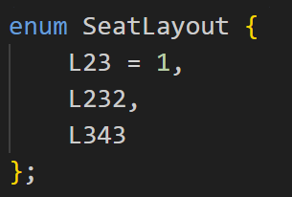

The SeatLayout function is a enumeration (enum). It lists the various seat layouts (2-3),(2-3-2)& (3-4-3).

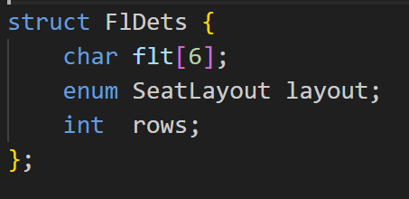

Struct FlDets {char flt[6]; enum SeatLayout layout; int rows}

The Flight Details (FlDets) is a structure which holds the following fields-
- char flt- Stores Flight Names
- enum SeatLayout layout- SeatLayout enum called with variable name layout
- rows- Represents number of rows present in the aircraf

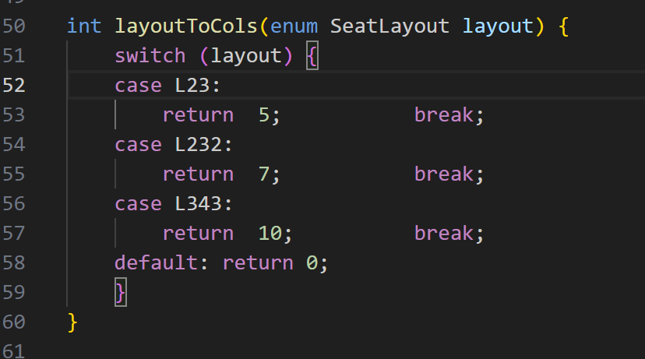

The function layoutToCols is used to determine number of columns in seating based on the layout. It uses switch to handle different layouts. Each of the case returns the total number of columns in it (for eg- if layout is L232 it returns 7)

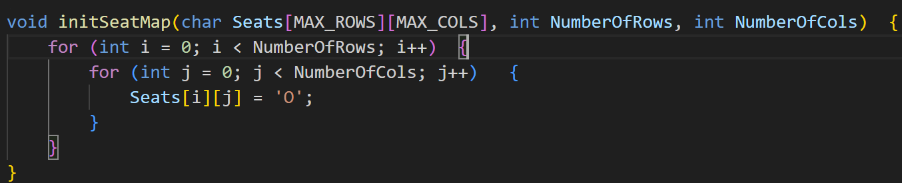

Initializes the seat map

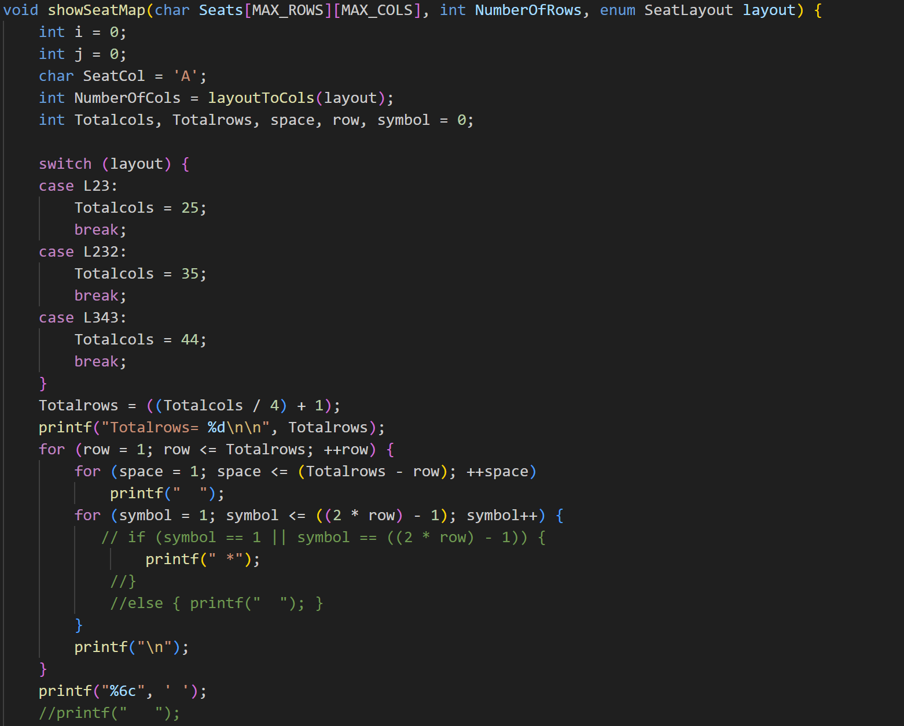

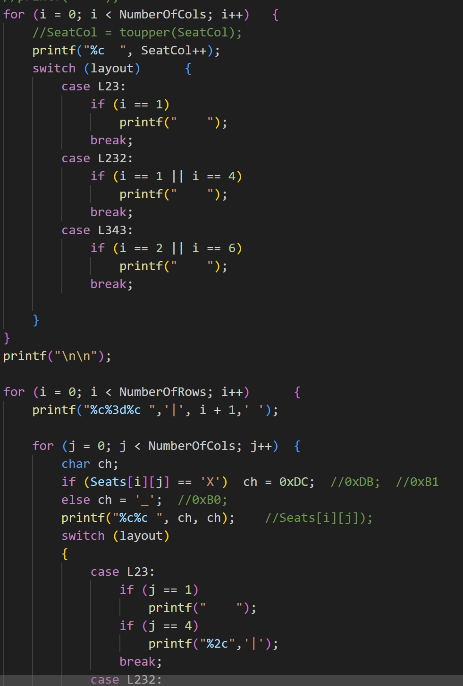

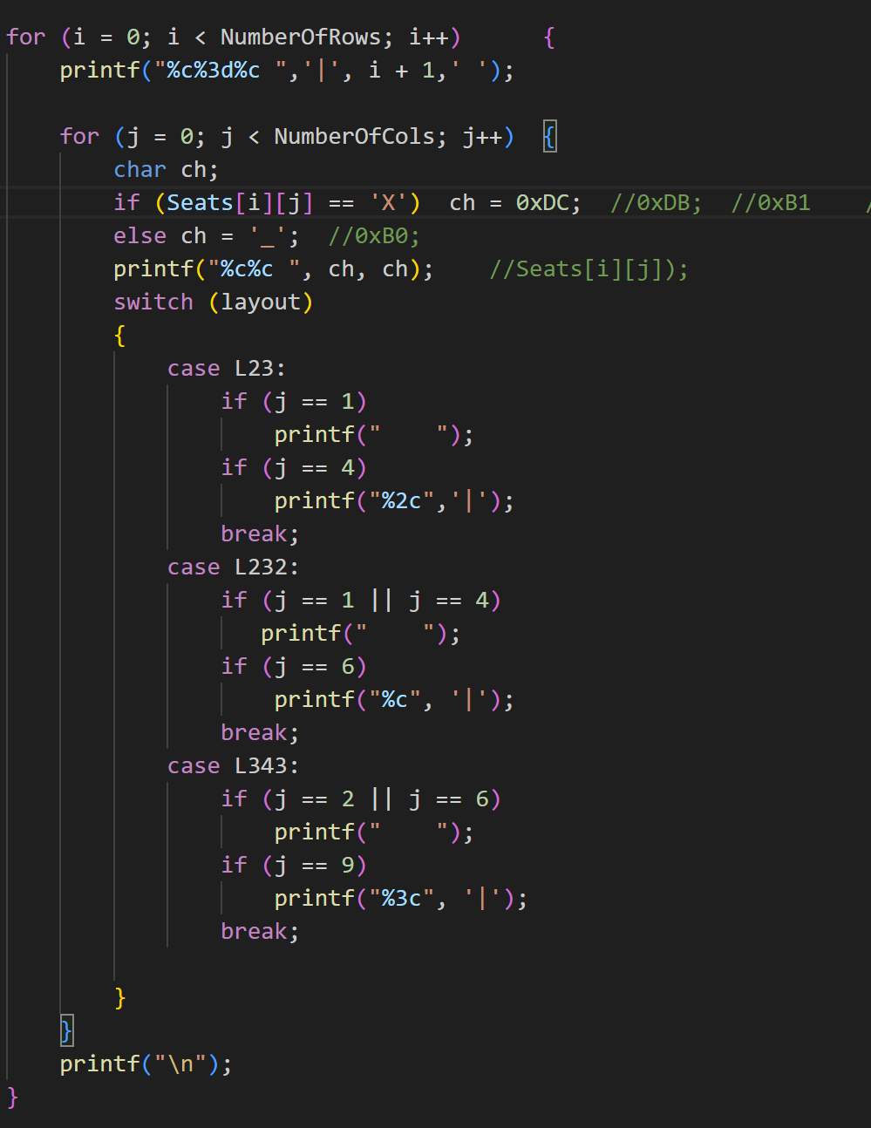

The function showSeatMap gets the no. of columns for the required layout by calling the layoutToCols function to print the column names as Capital Letters ‘A, B,C’ etc. It switches to the correct layout in the switch case by switching (layout) and formats the output in the terminal. After that it it prints the seatmap in the terminal with underscores (_) for available seats and replaces the X’s of the booked seats with a different char whose ASCII code is 0xDC. It then formats the spacing between the seats.

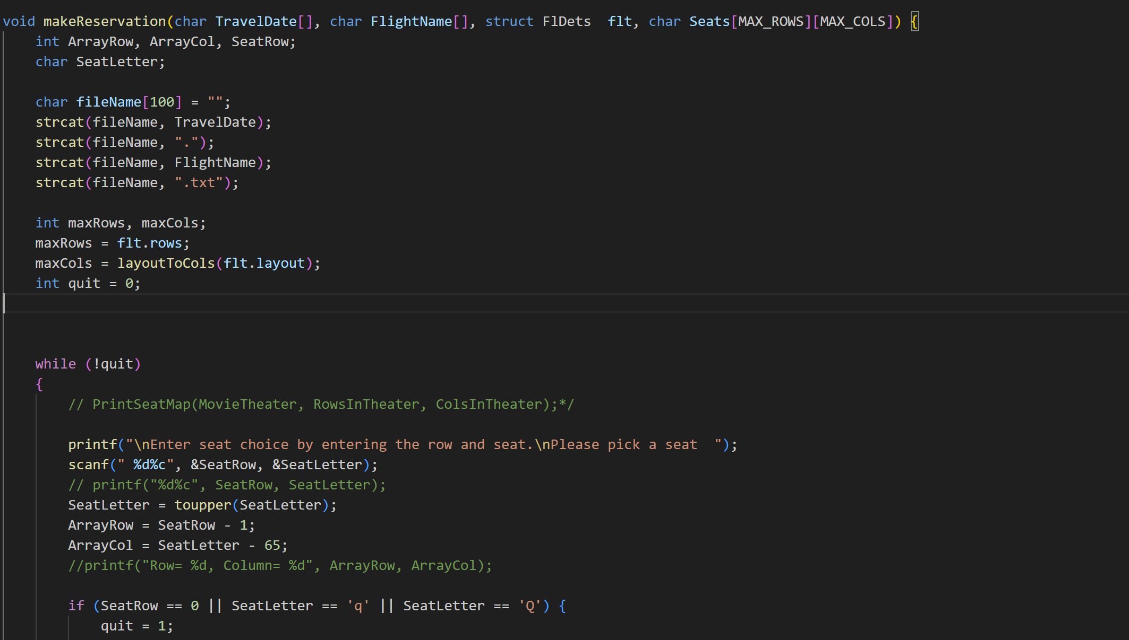
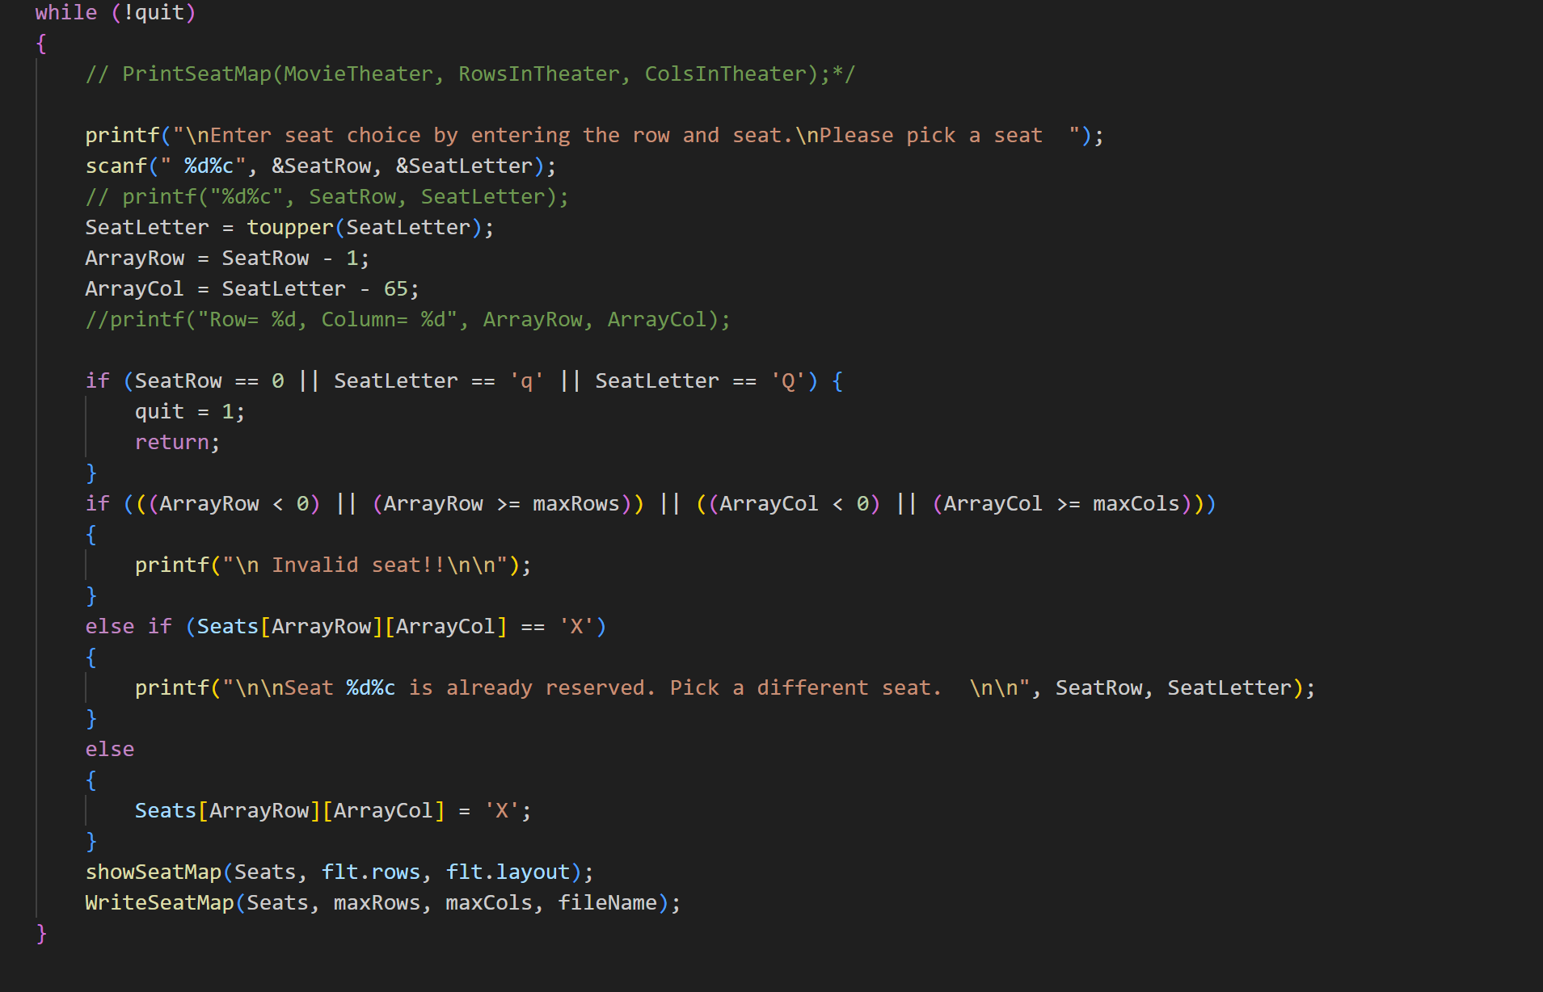

One of the main functions of the program, it asks the user to enter a seat preference. If the seat is already booked, it displays a message accordingly. In case user inputs invalid seat, appropriate message is displayed. If seat is available, it replaces it with an ‘X’ to show that it is now booked.
It also calls the functions showSeatMap to print the seat map and the function WriteSeatMap to save the seat map in the text file.

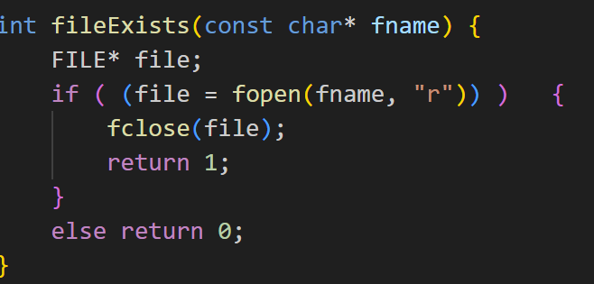

A function to check if file exists or not. If file exists it returns 1 else not then it returns 0. It is called in function named readSeatsFile.

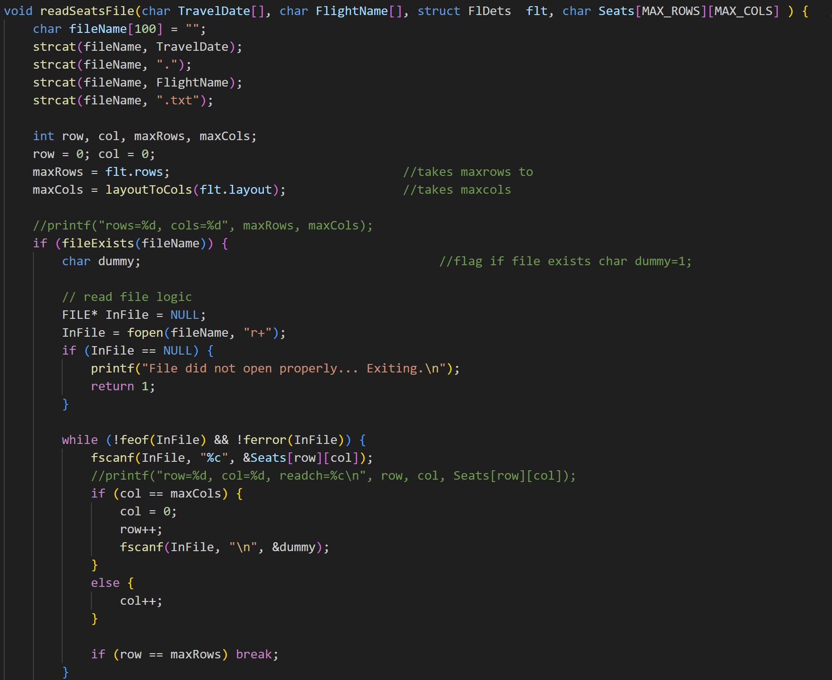

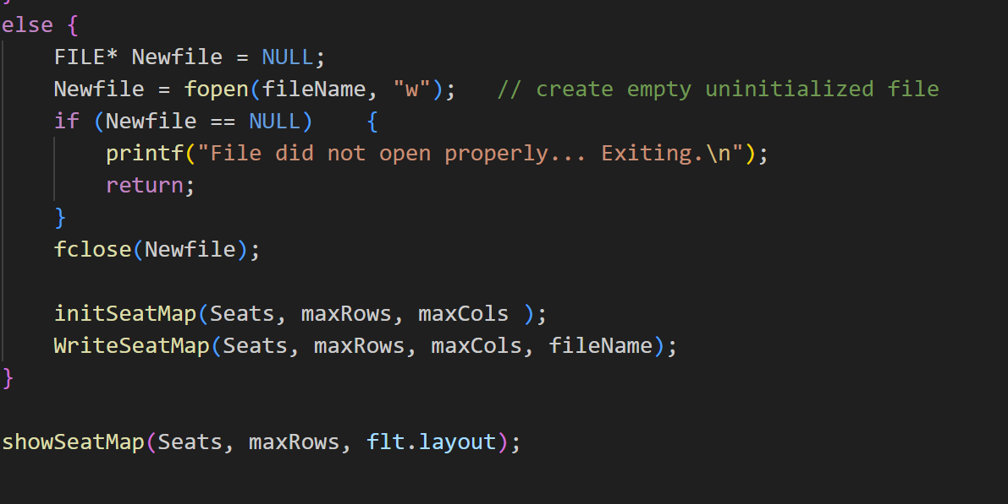
Another important function- readSeatsFile. It performs the following task-
Checks if file opened correctly by calling function fileExsists (refer to bullet point 10)

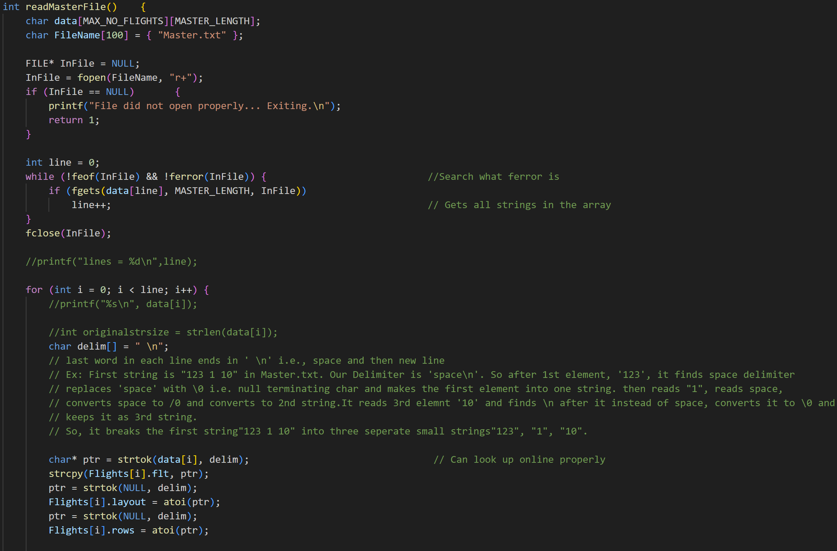

This function readMasterFile reads from the file Master.txt which contains the information of each flight in each string and it has an array of these strings for all the flights. It checks if file Master.txt opens or not and prints so. After that, it breaks the strings into its elements, i.e., the flight name, layout no., no. and no. of rows in seatmap of each flight by using function strtok which tokenizes the the array element to the delim(delimiter) as defined. It reads the flight layout and no. of rows as integer instead of string value with the
help of atoi function.

- (TO CONFIRM ONCE)

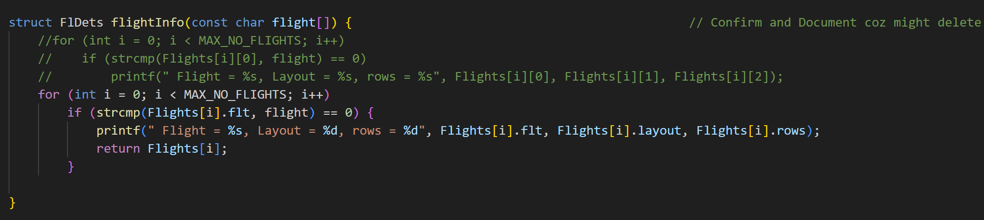

Fetches flight details and stores them

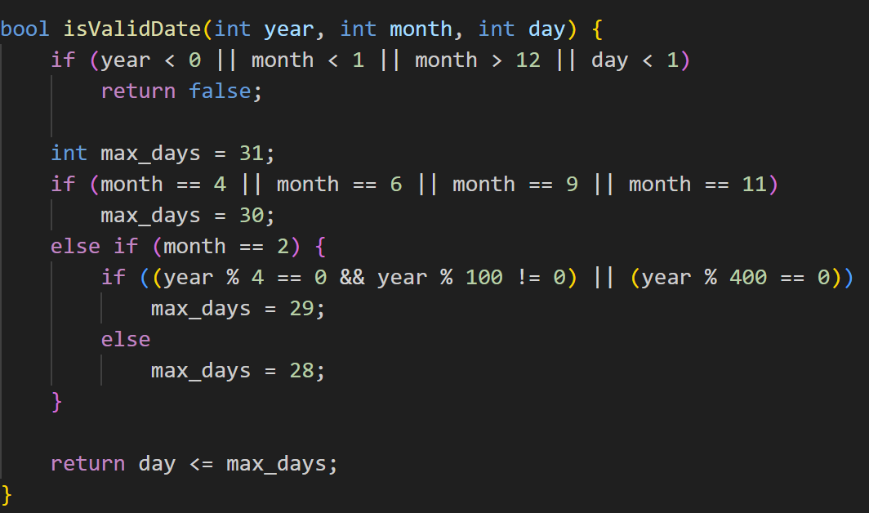

The Boolean function isValidDate checks the date entered by user in the function askDate. It uses loops to check validity of date entered. (eg- if month>12 it returns false,etc)

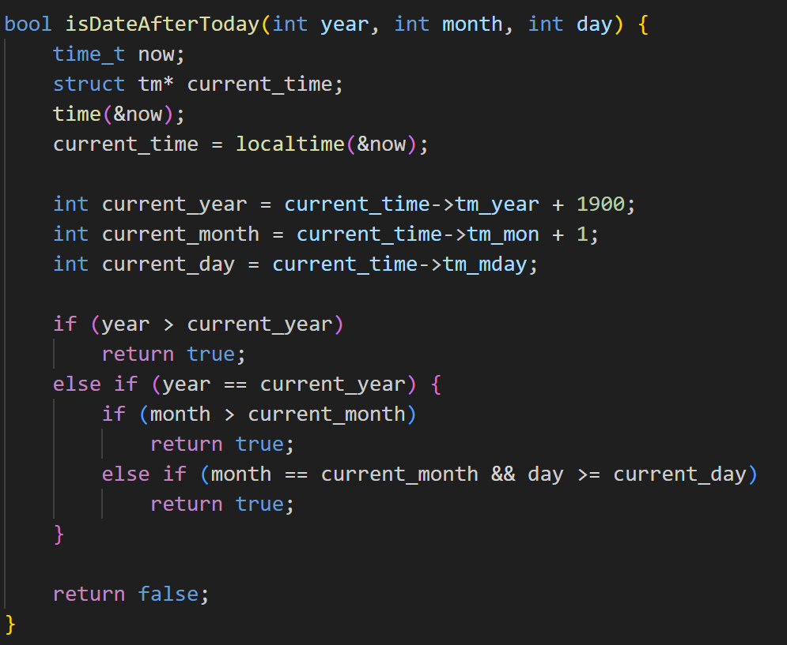

The Boolean function isDateAfterToday uses the “time” library of C to fetch date from system and check if user entered date is after the current date (since you can’t make changes on a flight that already flew yesterday).

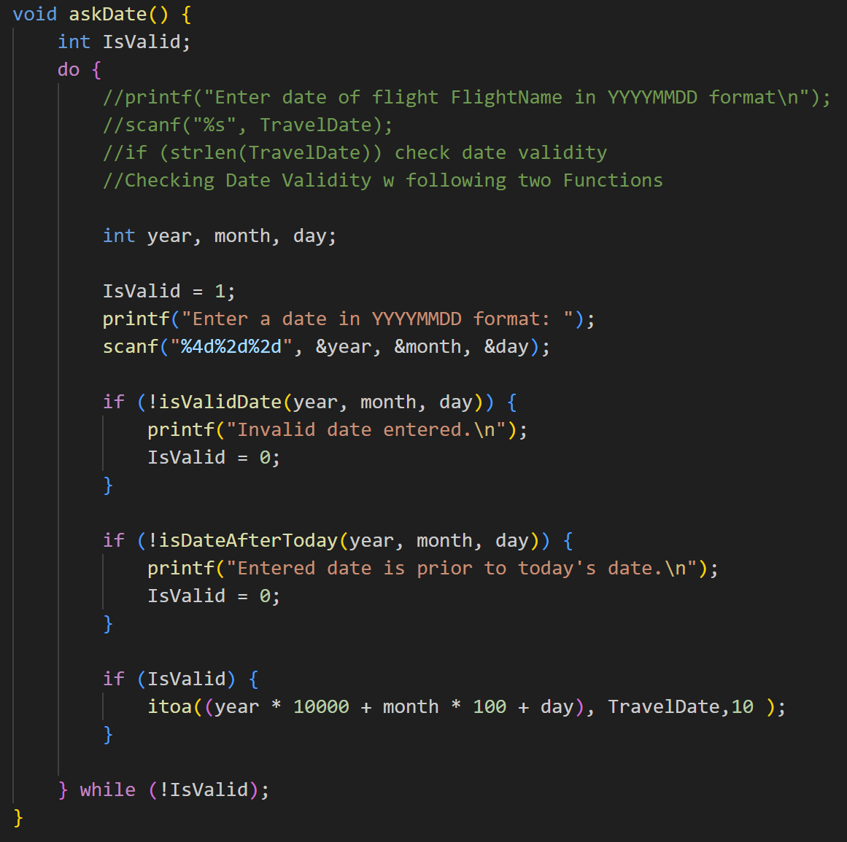

Function asks user to input date and then calls functions isValidDate & isDateAfterToday to check validity of date.

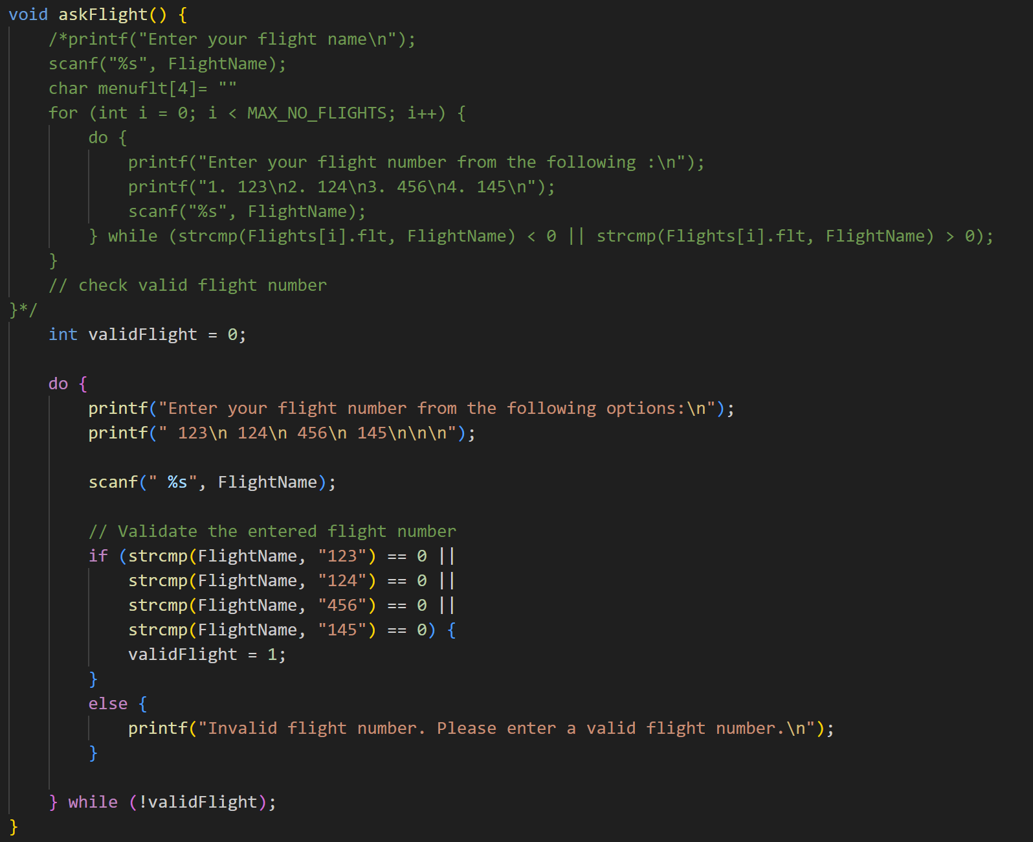

void askFlight function presents the flight options and asks user to enter their flight. The program keeps asking user to enter their flight number until they enter a valid flight number.

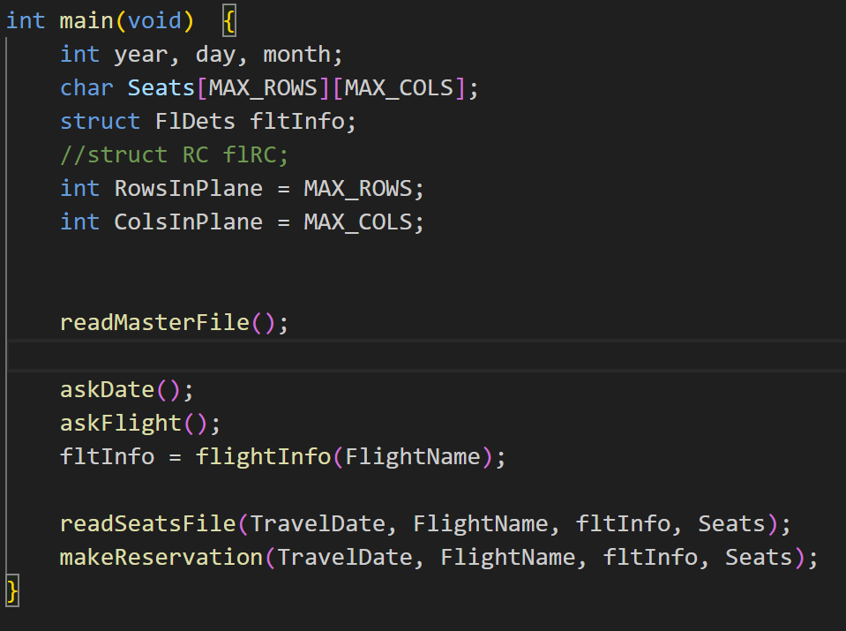

int main- Contains the different function calls

Project (Input/ Output) Specification

The project takes following inputs from user-

- Program fetches data from text file called Master.txt
- Date of Flight (YYYYMMDD)- The program handles incorrect dates by asking user to reenter the date.
- Flight Number- It shows a list of flight numbers and asks user to select their flight number.
- Asks user to pick a seat.

The program display following output-
- Seat Map of selected flight
- Seats already reserved
- Seats available
- Program stores updated seat map in text file named Master.txt

DESIGN and CODES:

Module Menu Screen

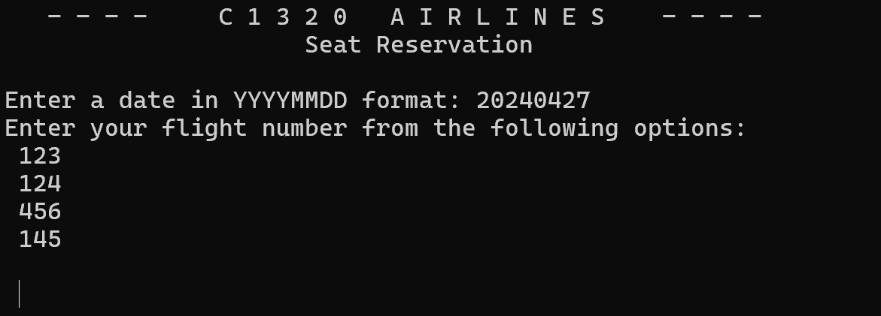

Greets user and allows them to select one of the available flights

PROGRAM TESTING
Test Log
Tester- Ved

- If user enters past date (before todays date)-

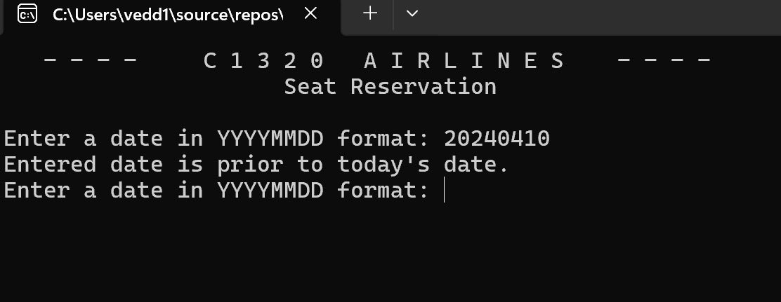

- User selects invalid date (534 April doesn’t exsist)

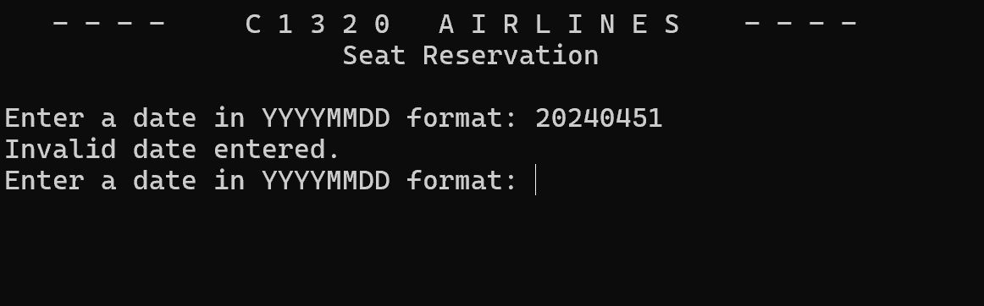

- User selects 2 seats in flight 123 on 23rd April 2024

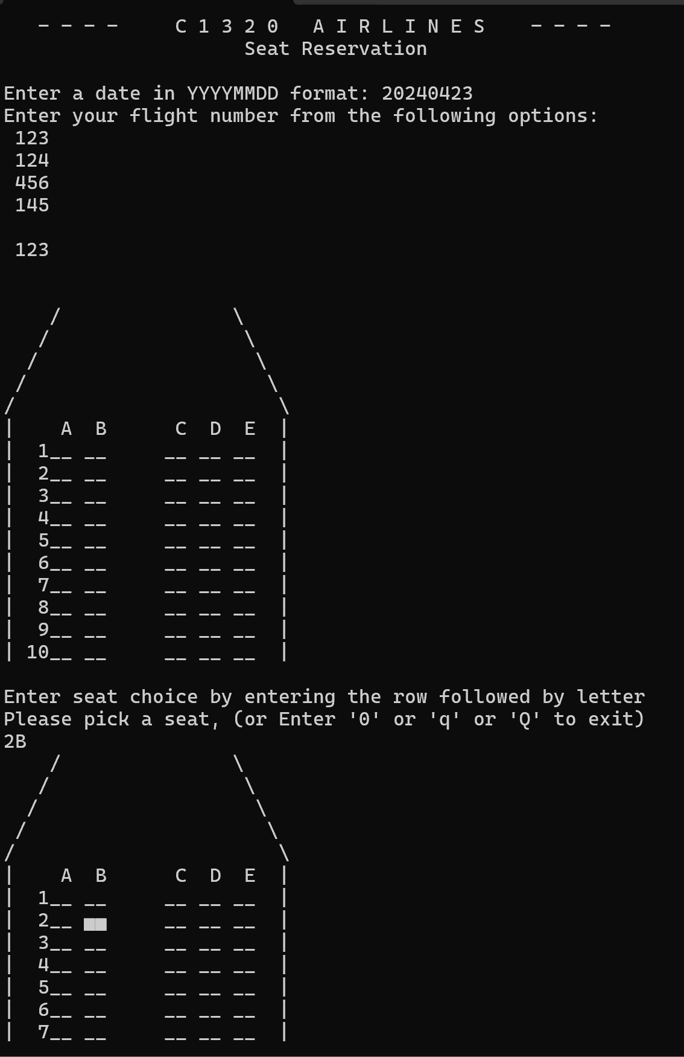

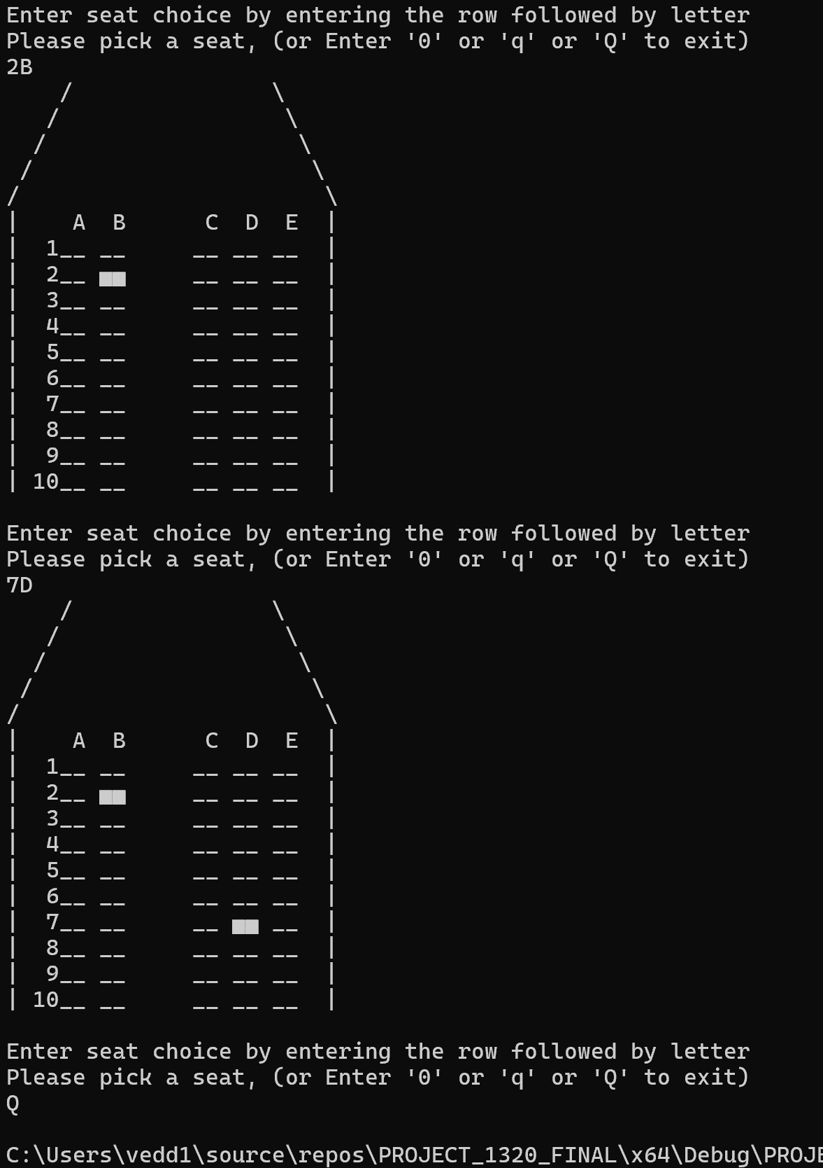

- User selects seats on flight 124 on 26th April

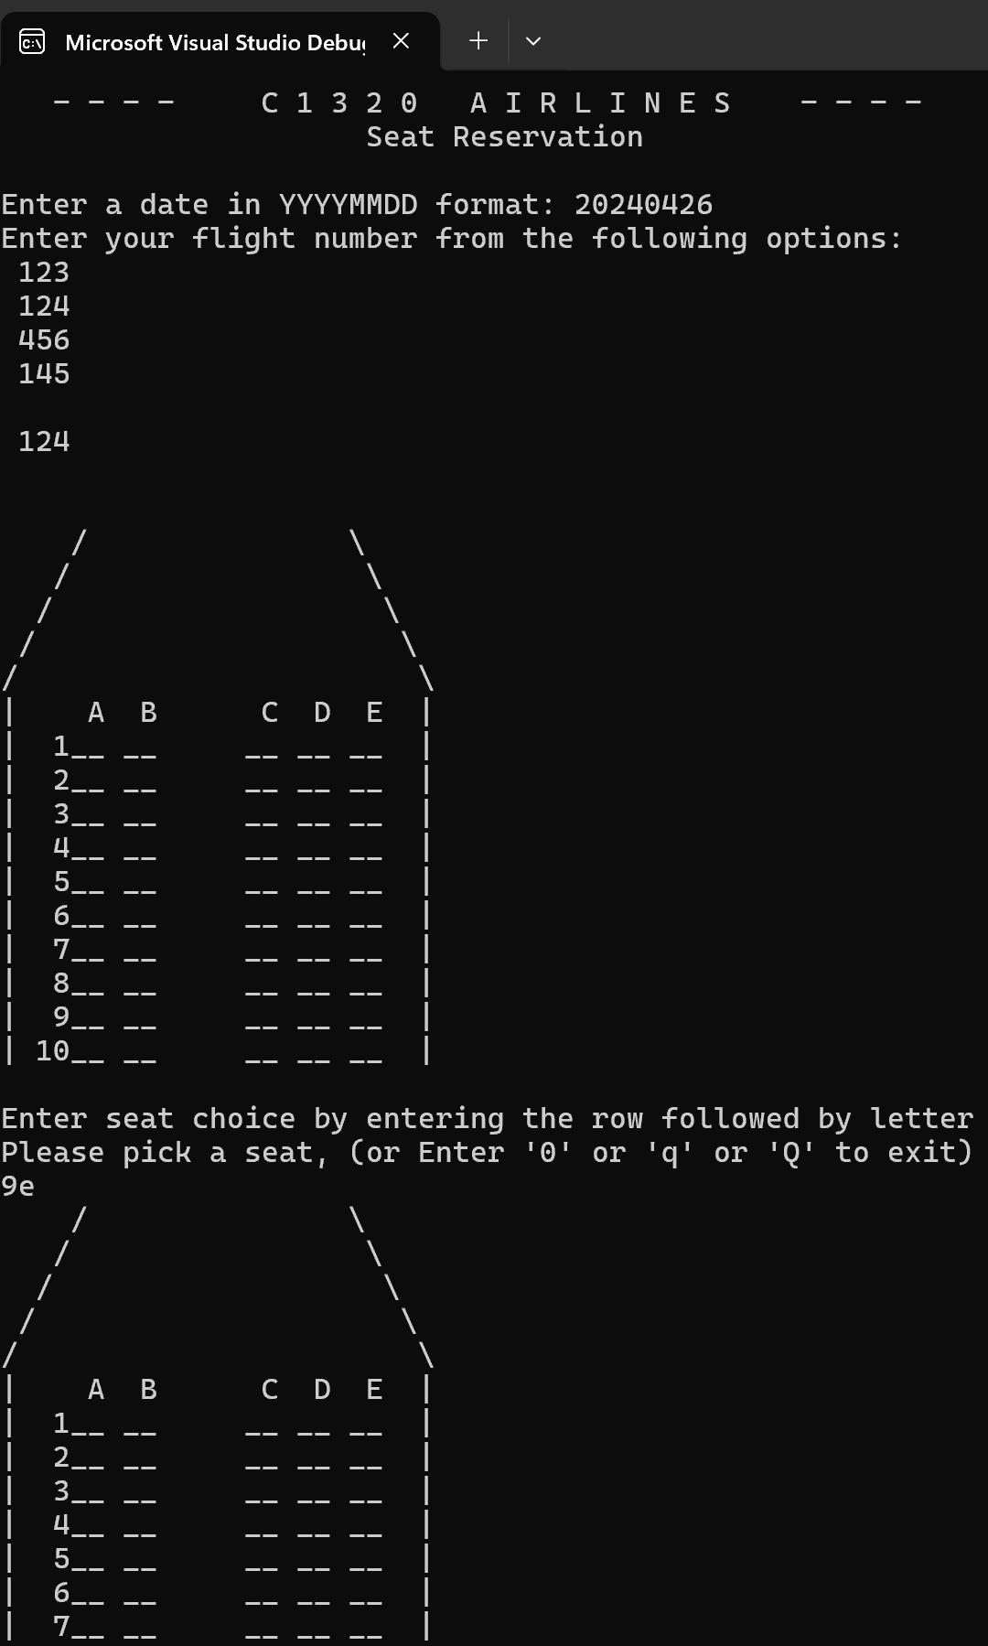

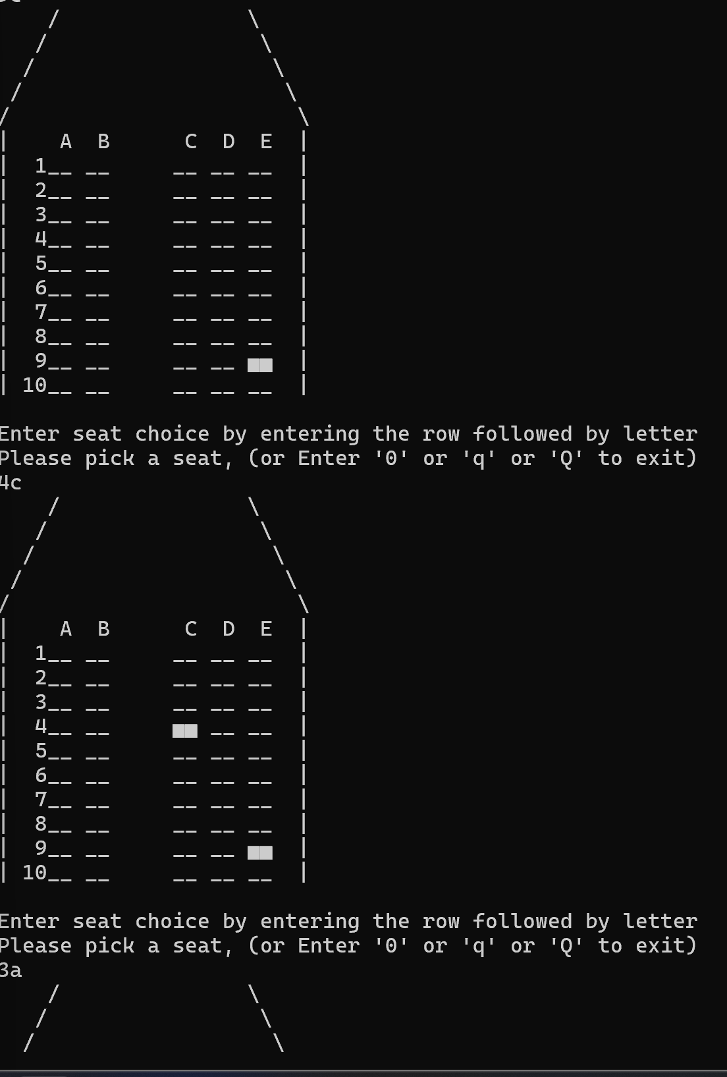

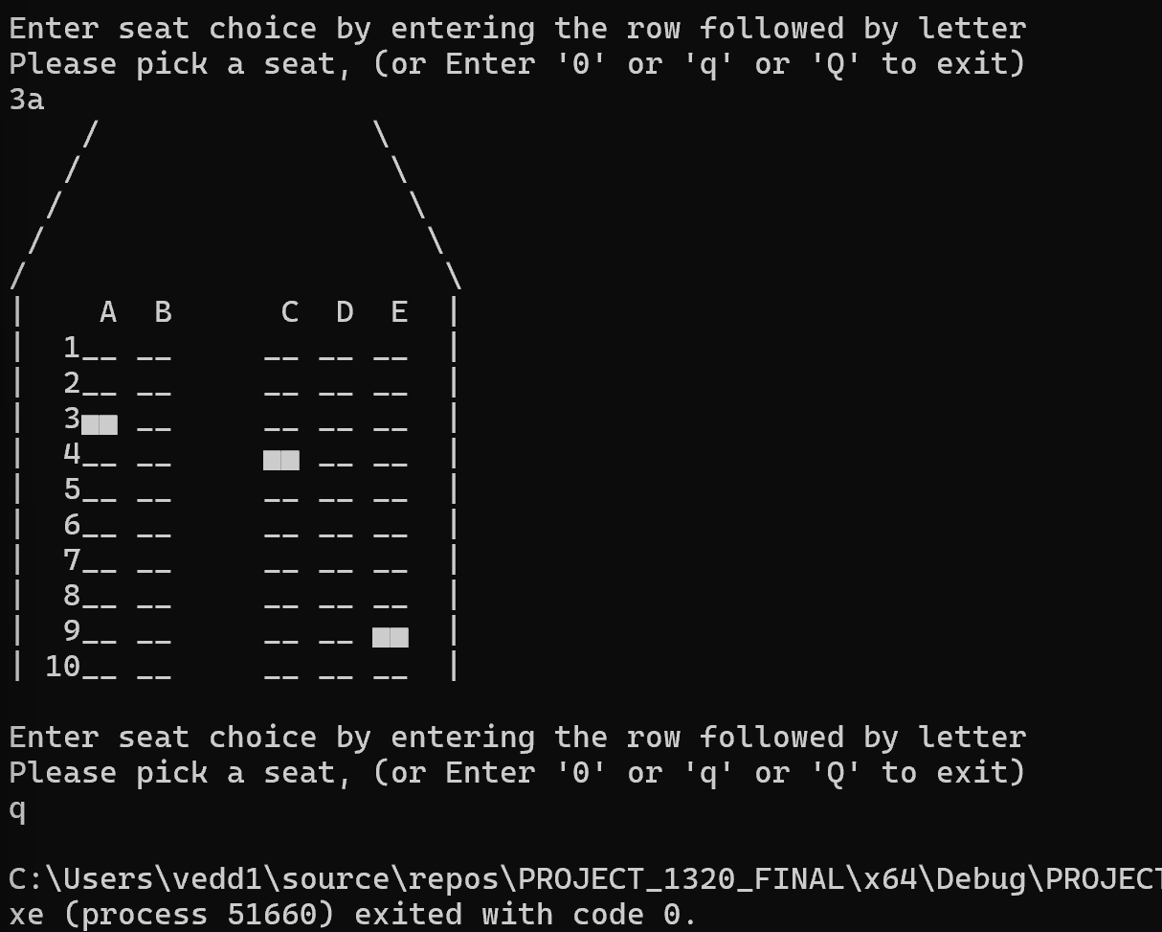

- User selects seats on flight 456 on 12th May. They select seats 12D, 11A then try to select 12D again which is already booked so, appropriate message is displayed.

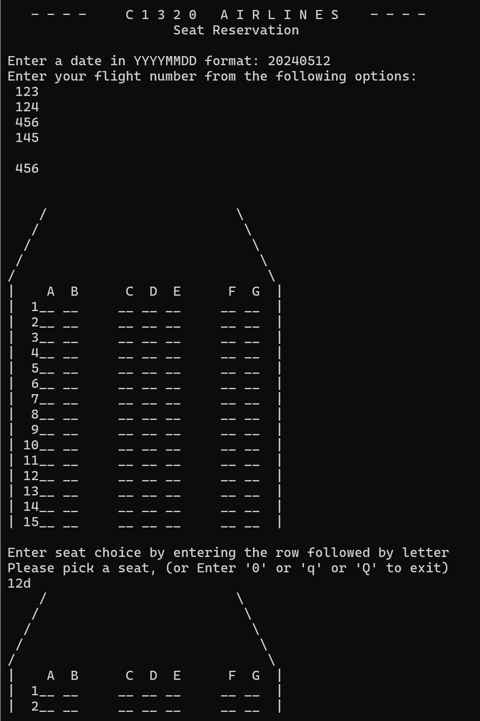

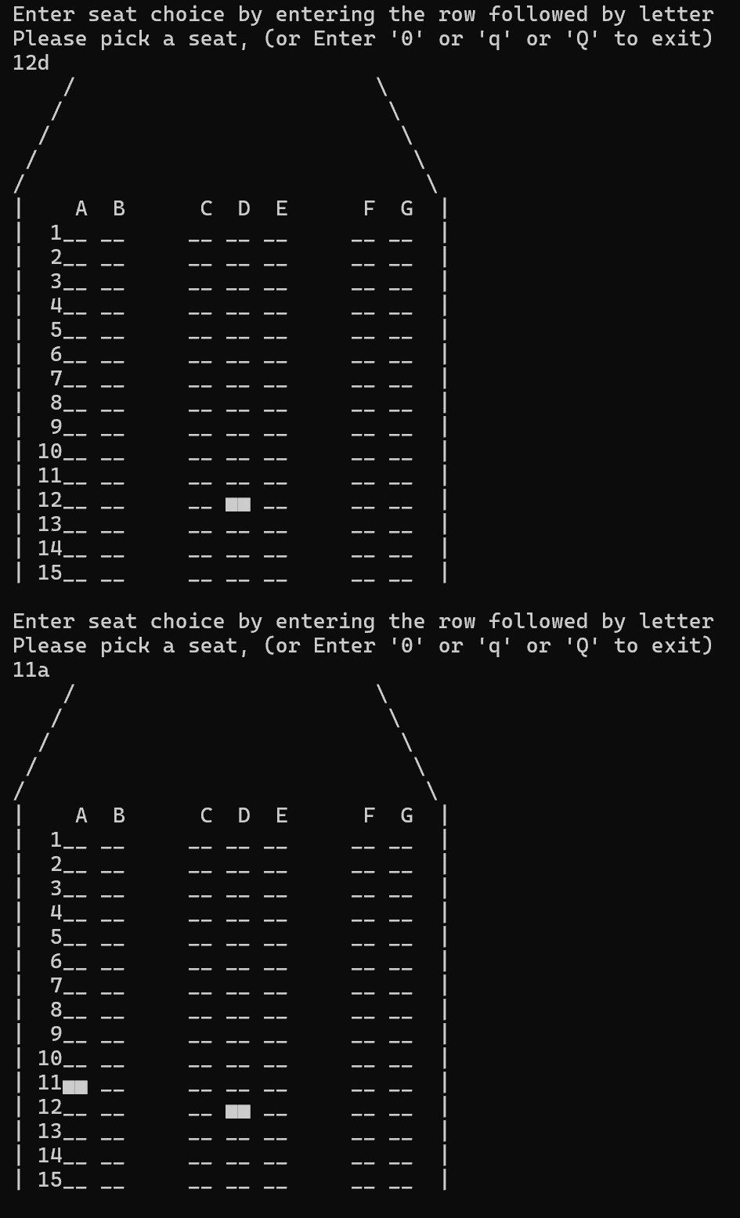

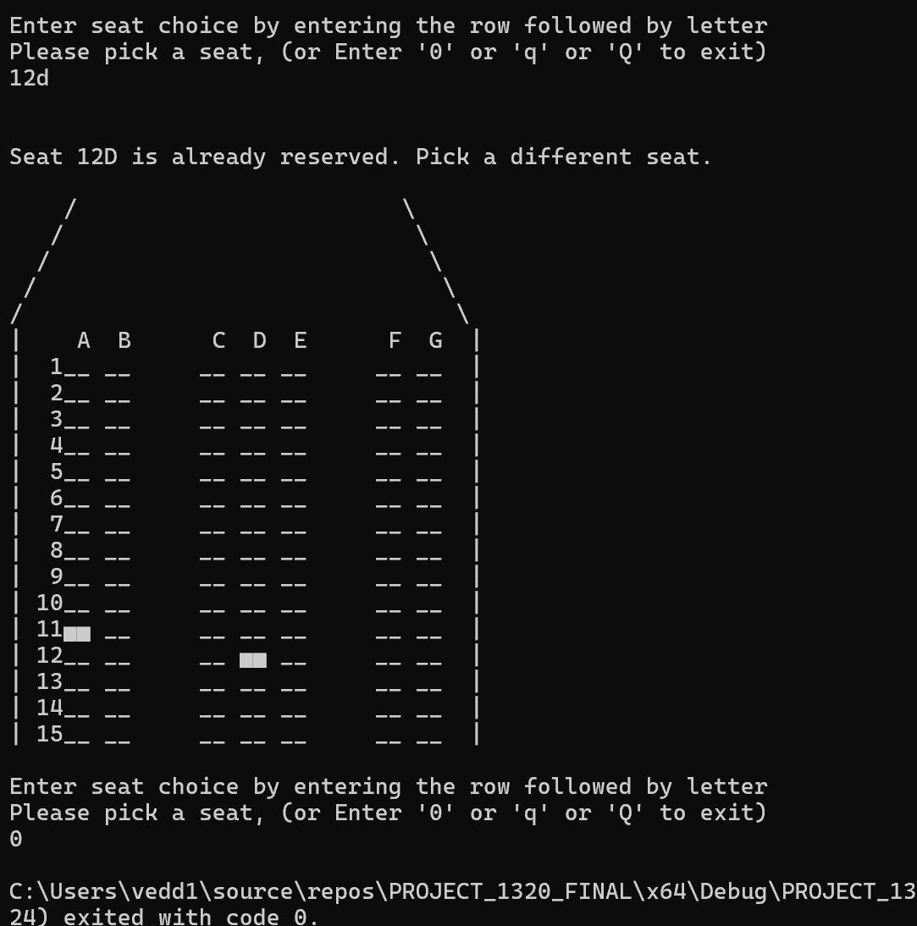

- User enters flight 145 dated 30th April

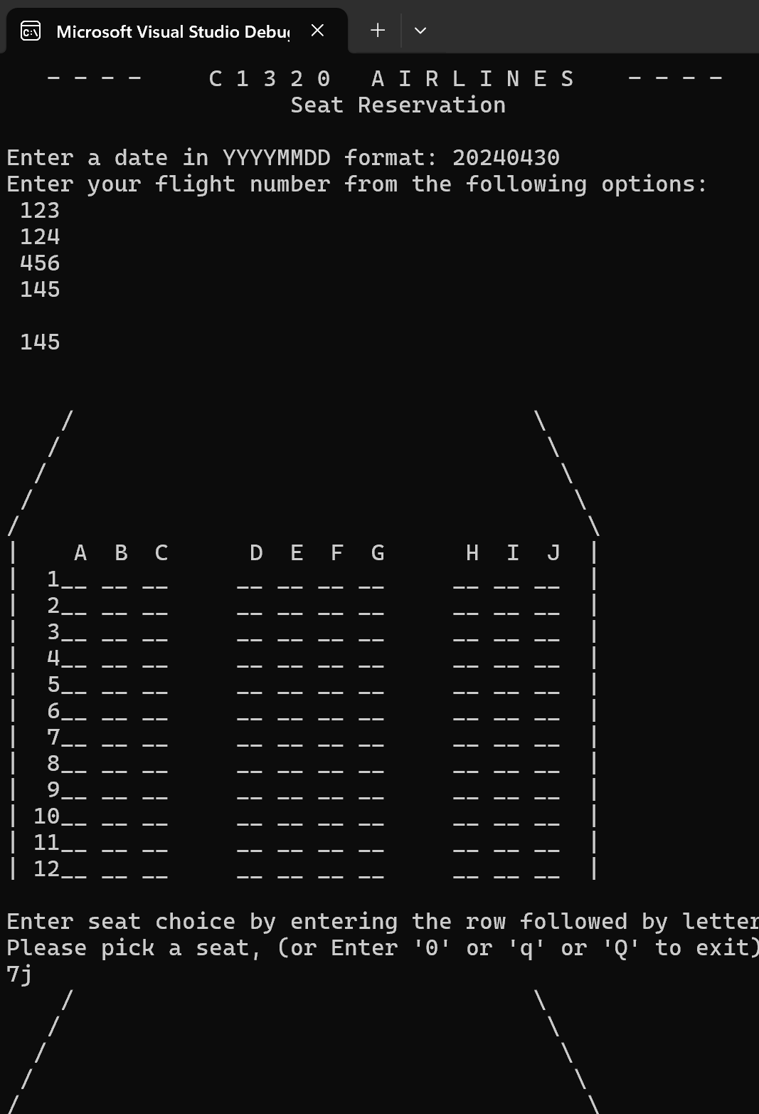

- 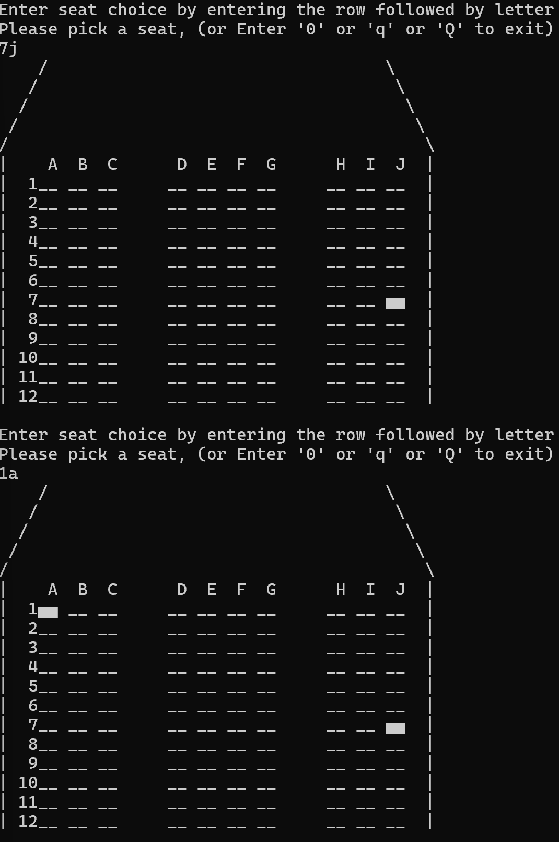

- 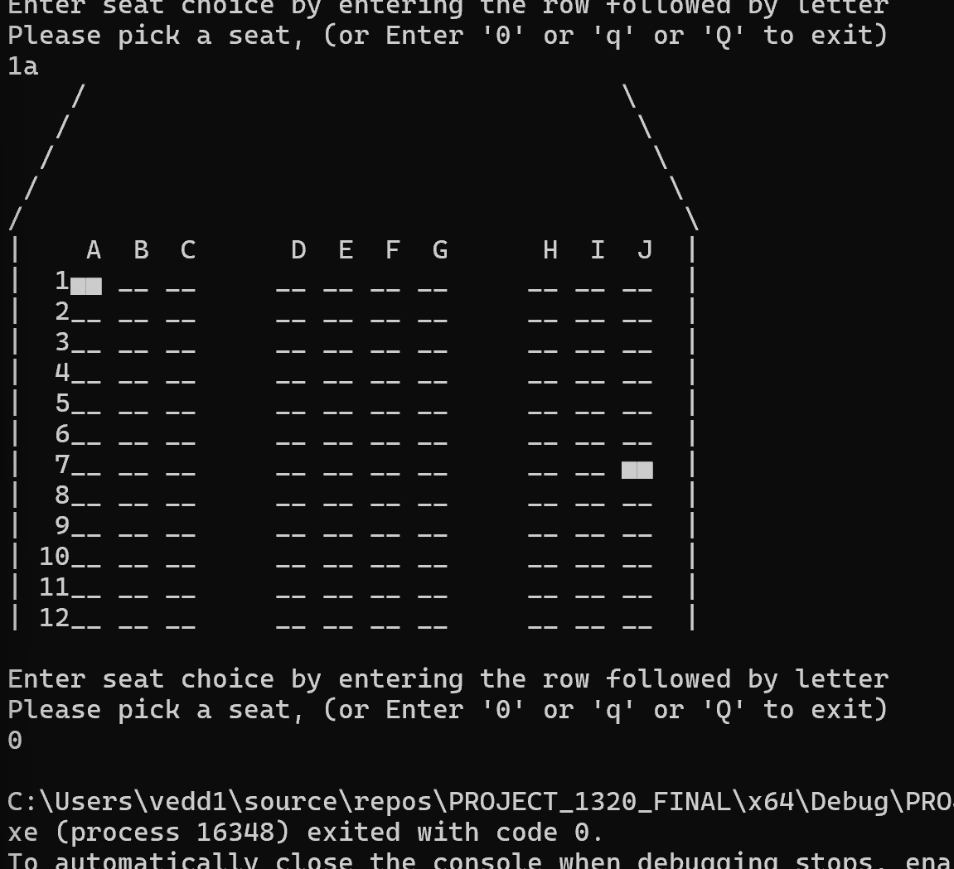

CONCLUSION

- Project Weakness:

Difficulty in Organizing Code: While writing the code, we encountered challenges in organizing it into a well-structured and concise form with fewer functions. Although the program benefits from its modular structure, the extensive use of functions has led to a longer codebase. Simplifying the code while maintaining clarity could enhance readability and maintainability.

- Project Strength:

- Modular Structure: Our code is well-organized into functions, ensuring modularity and enhancing readability. Each function serves a specific purpose, contributing to maintainability and ease of understanding.

- Input Validation: we implemented input validation in functions like isValidDate() and isDateAfterToday(), ensuring that the user enters valid data. For example:

Date Validation: When a user enters a date prior to the current date, the program notifies them with a clear message such as "Entered date is prior to today's date. Please enter a date in YYYYMMDD format."
Invalid Date Format: If a user enters an invalid date format or a non-existent date (e.g., "534d April"), the program responds with an informative message like "Invalid date entered. Please enter a valid date in YYYYMMDD format."

providing informative messages to users like this, when invalid inputs are detected, improves usability and helps users understand and correct their mistakes.

- Detailed Function Descriptions: Each function used in the program is described in detail, including its purpose and the tasks it performs. This makes it easier for developers to understand and modify the code in the future.

- Project Enhancement:

- Code Optimization Strategies:

- We should examine functions that serve similar purposes and merge them to minimize repetition and make the code more straightforward.

- Combining small helper functions or those with limited usage into larger functions can reduce the number of function calls and enhance the overall readability of the code.

- We considered adding an in-flight meal booking system but decided against it due to the existing complexity of our codebase, which already contains numerous functions.

Appendix:

#include <ctype.h>
#include <stdio.h>
#include <string.h>
#include <stdlib.h>
#include <stdbool.h>
#include <time.h>

#pragma warning(disable : 4996)

# define MAX_COLS 10
# define MAX_ROWS 20
# define MAX_LINE 20
# define MAX_NO_FLIGHTS 10
# define MASTER_LENGTH 20
# define BOOKING_LENGTH 20
//# define TICKET_LIMIT 4

enum SeatLayout {
L23 = 1,
L232,
L343
};

struct FlDets {
char flt[6];
enum SeatLayout layout;
int rows;
};

/*struct RC {
int row;
int col;
};*/

/*int layout[3][4] =
{ { L23 , 5 , 2 , 99 }, // no of cols=5, 1st aisle after 2cols, 2nd aisle after 99 cols(does not exist)
{ L232, 7 , 2 , 5 }, // no. of cols=7, 1st aisle after 2 cols, 2nd aisle after 5 aisles
{ L343, 10, 3 , 7 }, // no. of cols=10, 1st aisle after 3 cols, 2nd aisle after 7 cols
};
*/
//char Flights[MAX_NO_FLIGHTS][3][10];
struct FlDets Flights[MAX_NO_FLIGHTS];

int layoutToCols(enum SeatLayout layout) {
switch (layout) {
case L23:
return 5; break;
case L232:
return 7; break;
case L343:
return 10; break;
default: return 0;
}
}

void initSeatMap(char Seats[MAX_ROWS][MAX_COLS], int NumberOfRows, int NumberOfCols) {
for (int i = 0; i < NumberOfRows; i++) {
for (int j = 0; j < NumberOfCols; j++) {
Seats[i][j] = 'O';
}
}
}

void showSeatMap(char Seats[MAX_ROWS][MAX_COLS], int NumberOfRows, enum SeatLayout layout) {
int i = 0;
int j = 0;
char SeatCol = 'A';
int NumberOfCols = layoutToCols(layout);
int Totalcols, Totalrows, space, row, symbol = 0;

switch (layout) {
case L23:
Totalcols = 25;
break;
case L232:
Totalcols = 34;
break;
case L343:
Totalcols = 44;
break;
}
Totalrows = ((Totalcols / 4) + 1);
//printf("Totalrows= %d\n\n", Totalrows);
//for (row = 1; row <= Totalrows; ++row) {
// for (space = 1; space <= (Totalrows - row); ++space)
// printf(" ");
// for (symbol = 1; symbol <= ((2 * row) - 1); symbol++) {
// if (row == 1 && symbol == 1) {
// printf("%c", '^');
// }
// else if (symbol == 1 ){
// printf("%1c",'/');
// }
// else if (symbol == ((2 * row) - 2)) {
// printf("%c",'\\');
// }
// else { printf(" "); }
// }
// printf("\n");
//}

for (int r = 5; r >= 1; r--) {
for (int j = 2; j <= r; j++)
printf("%c", ' ');
printf("%c", '/');
for (int c = 1; c <= Totalcols - ( r*2) ; c++)
printf("%c", ' ');
printf("%c\n", '\\');

}

printf("%c%4c",'|', ' ');
//printf(" ");
for (i = 0; i < NumberOfCols; i++) {
//SeatCol = toupper(SeatCol);
printf("%c ", SeatCol++);
switch (layout) {
case L23:
if (i == 1)
printf(" ");
break;
case L232:
if (i == 1 || i == 4)
printf(" ");
break;
case L343:
if (i == 2 || i == 6)
printf(" ");
break;

}
}
printf("%c", '|');
printf("\n");

// used a character from "charmap.exe" in terminal font bcoz it looks good// 0xDC is the ASCII code of used char
for (i = 0; i < NumberOfRows; i++) {
printf("%c%3d",'|', i + 1);

for (j = 0; j < NumberOfCols; j++) {
char ch;
if (Seats[i][j] == 'X') ch = 0xDC; //0xDB; //0xB1
else ch = '_'; //0xB0;
printf("%c%c ", ch, ch); //Seats[i][j]);
switch (layout)
{
case L23:
if (j == 1)
printf(" ");
if (j == 4)
printf(" |");
break;
case L232:
if (j == 1 || j == 4)
printf(" ");
if (j == 6)
printf(" |");
break;
case L343:
if (j == 2 || j == 6)
printf(" ");
if (j == 9)
printf(" |");
break;

}
}
printf("\n");
}
}

void WriteSeatMap(const char Seats[MAX_ROWS][MAX_COLS], int NumberOfRows, int NumberOfCols, const char fileName[])
{
FILE* outFile = NULL;

outFile = fopen(fileName, "w+");
if (outFile == NULL) {
printf("A file did not open properly... Exiting.\n");
exit(0);
}

//fprintf(outFile, "%d %d\n", NumberOfRows, NumberOfCols); first line gives rows cols
for (int i = 0; i < NumberOfRows; i++) {
for (int j = 0; j < NumberOfCols; j++) {
fprintf(outFile, "%c", Seats[i][j]);
}
fprintf(outFile, "\n");
}
fclose(outFile);
}

void makeReservation(char TravelDate[], char FlightName[], struct FlDets flt, char Seats[MAX_ROWS][MAX_COLS]) {
int ArrayRow, ArrayCol;
int SeatRow = 0;
char SeatLetter = ' ';

char fileName[100] = "";
strcat(fileName, TravelDate);
strcat(fileName, ".");
strcat(fileName, FlightName);
strcat(fileName, ".txt");

int maxRows, maxCols;
maxRows = flt.rows;
maxCols = layoutToCols(flt.layout);
int quit = 0;
char input[4];
//int number;
//int letter;

int invalidSeat = 0;
while (!quit)
{

if (invalidSeat == 1) {
printf("\n Invalid seat %s -- Please enter a valid choice..",input);
invalidSeat = 0;
}
printf("\nEnter seat choice by entering the row followed by letter \n");
printf("Please pick a seat, (or Enter '0' or 'q' or 'Q' to exit) \n");
//scanf(" %d%c", &SeatRow, &SeatLetter); //
// printf("%d%c", SeatRow, SeatLetter);
scanf("%s", input);
//printf("%s", input);
char* ptr = input;

if (*ptr == 'q' || *ptr == 'Q' || *ptr == '0') {
quit = 1; return;
}

int num = 0;
while (*ptr != '\0' && isdigit(*ptr)) { //Find the position of the first non-digit character
num = (num * 10) + (*ptr - '0');
ptr++;
}

if (num == 0) {
invalidSeat = 1; continue;
}
char ch = *ptr;
ch = toupper(ch);
if (!(ch >= 'A' && ch <= 'J')) {
invalidSeat = 1; continue;
}
// Convert the digits before the non-digit character to an integer
/* *ptr = '\0'; // Terminate the string at the non-digit character
SeatRow = atoi(input);

// Move the pointer to the next character after digit and \0 the non-digit character
ptr++;

// Read the next character as a char
if (*ptr != '\0') {
SeatLetter = *ptr;
}
*/
SeatRow = num; SeatLetter = ch;
//printf("%d , %c", SeatRow, SeatLetter);
SeatLetter = toupper(SeatLetter);
ArrayRow = SeatRow - 1;
ArrayCol = SeatLetter - 65;
//printf("Row= %d, Column= %d", ArrayRow, ArrayCol);

if (SeatRow == 0 || SeatLetter == 'q' || SeatLetter == 'Q') {
quit = 1;
return;
}
if (((ArrayRow < 0) || (ArrayRow >= maxRows)) || ((ArrayCol < 0) || (ArrayCol >= maxCols)))
{
printf("\n Invalid seat!!\n\n");
}
else if (Seats[ArrayRow][ArrayCol] == 'X')
{
printf("\n\nSeat %d%c is already reserved. Pick a different seat. \n\n", SeatRow, SeatLetter);
}
else
{
Seats[ArrayRow][ArrayCol] = 'X';
}
showSeatMap(Seats, flt.rows, flt.layout);
WriteSeatMap(Seats, maxRows, maxCols, fileName);
}
}

int fileExists(const char* fname) {
FILE* file;
if ( (file = fopen(fname, "r")) ) {
fclose(file);
return 1;
}
else return 0;
}

void readSeatsFile(char TravelDate[], char FlightName[], struct FlDets flt, char Seats[MAX_ROWS][MAX_COLS] ) { // What does this do
char fileName[100] = "";
strcat(fileName, TravelDate);
strcat(fileName, ".");
strcat(fileName, FlightName);
strcat(fileName, ".txt");

int row, col, maxRows, maxCols;
row = 0; col = 0;
maxRows = flt.rows; //takes maxrows to
maxCols = layoutToCols(flt.layout); //takes maxcols

//printf("rows=%d, cols=%d", maxRows, maxCols);
if (fileExists(fileName)) {
char dummy; //flag if file exists char dummy=1;

// read file logic
FILE* InFile = NULL;
InFile = fopen(fileName, "r+");
if (InFile == NULL) {
printf("File did not open properly... Exiting.\n");
return ;
}

while (!feof(InFile) && !ferror(InFile)) {
fscanf(InFile, "%c", &Seats[row][col]);
//printf("row=%d, col=%d, readch=%c\n", row, col, Seats[row][col]);
if (col == maxCols) {
col = 0;
row++;
fscanf(InFile, "\n", &dummy);
}
else {
col++;
}

if (row == maxRows) break;
}
fclose(InFile);

}
else {
FILE* Newfile = NULL;
Newfile = fopen(fileName, "w"); // create empty uninitialized file
if (Newfile == NULL) {
printf("File did not open properly... Exiting.\n");
return;
}
fclose(Newfile);

initSeatMap(Seats, maxRows, maxCols );
WriteSeatMap(Seats, maxRows, maxCols, fileName);
}

showSeatMap(Seats, maxRows, flt.layout);
}

int readMasterFile() {
char data[MAX_NO_FLIGHTS][MASTER_LENGTH];
char FileName[100] = { "Master.txt" };

FILE* InFile = NULL;
InFile = fopen(FileName, "r+");
if (InFile == NULL) {
printf("File did not open properly... Exiting.\n");
return 1;
}

int line = 0;
while (!feof(InFile) && !ferror(InFile)) { // feof = end of file //ferror =
if (fgets(data[line], MASTER_LENGTH, InFile))
line++; // Gets all strings in the array
}
fclose(InFile);

//printf("lines = %d\n",line);

for (int i = 0; i < line; i++) {
//printf("%s\n", data[i]);

//int originalstrsize = strlen(data[i]);
char delim[] = " \n";
// last word in each line ends in ' \n' i.e., space and then new line
// Ex: First string is "123 1 10" in Master.txt. Our Delimiter is 'space\n'. So after 1st element, '123', it finds space delimiter
// replaces 'space' with \0 i.e. null terminating char and makes the first element into one string. then reads "1", reads space,
// converts space to /0 and converts to 2nd string.It reads 3rd elemnt '10' and finds \n after it instead of space, converts it to \0 and
// keeps it as 3rd string.
// So, it breaks the first string"123 1 10" into three seperate small strings"123", "1", "10".

char* ptr = strtok(data[i], delim); // Can look up online properly
strcpy(Flights[i].flt, ptr);
ptr = strtok(NULL, delim);
Flights[i].layout = atoi(ptr);
ptr = strtok(NULL, delim);
Flights[i].rows = atoi(ptr);

}
}

char TravelDate[9] = { "20240330" }; // Just common declaration for variables used in all functions but not necessarily defined everywhere so to keep//not junk
char FlightName[6] = { "123" };

struct FlDets flightInfo(const char flight[]) { //Does this just print the output line orr is this code necessary
for (int i = 0; i < MAX_NO_FLIGHTS; i++) {
if (strcmp(Flights[i].flt, flight) == 0) {
// printf(" Flight = %s, Layout = %d, rows = %d", Flights[i].flt, Flights[i].layout, Flights[i].rows);
return Flights[i];
}
}
}

bool isValidDate(int year, int month, int day) {
if (year < 0 || month < 1 || month > 12 || day < 1)
return false;

int max_days = 31;
if (month == 4 || month == 6 || month == 9 || month == 11)
max_days = 30;
else if (month == 2) {
if ((year % 4 == 0 && year % 100 != 0) || (year % 400 == 0))
max_days = 29;
else
max_days = 28;
}

return day <= max_days;
}

bool isDateAfterToday(int year, int month, int day) {
time_t now;
struct tm* current_time;
time(&now);
current_time = localtime(&now);

int current_year = current_time->tm_year + 1900;
int current_month = current_time->tm_mon + 1;
int current_day = current_time->tm_mday;

if (year > current_year)
return true;
else if (year == current_year) {
if (month > current_month)
return true;
else if (month == current_month && day >= current_day)
return true;
}

return false;
}

void askDate() {
int IsValid;
do {

//Checking Date Validity w following two Functions

int year, month, day;

IsValid = 1;
printf("Enter a date in YYYYMMDD format: ");
scanf("%4d%2d%2d", &year, &month, &day);

if (!isValidDate(year, month, day)) {
printf("Invalid date entered.\n");
IsValid = 0;
}

if (!isDateAfterToday(year, month, day)) {
printf("Entered date is prior to today's date.\n");
IsValid = 0;
}

if (IsValid) {
itoa((year * 10000 + month * 100 + day), TravelDate,10 );
}

} while (!IsValid);
}

void askFlight() {
/*printf("Enter your flight name\n");
scanf("%s", FlightName);
char menuflt[4]= ""
for (int i = 0; i < MAX_NO_FLIGHTS; i++) {
do {
printf("Enter your flight number from the following :\n");
printf("1. 123\n2. 124\n3. 456\n4. 145\n");
scanf("%s", FlightName);
} while (strcmp(Flights[i].flt, FlightName) < 0 || strcmp(Flights[i].flt, FlightName) > 0);
}
// check valid flight number
}*/
int validFlight = 0;

do {
printf("Enter your flight number from the following options:\n");
printf(" 123\n 124\n 456\n 145\n\n ");

scanf(" %s", FlightName);
printf("\n\n");

// Validate the entered flight number
if (strcmp(FlightName, "123") == 0 ||
strcmp(FlightName, "124") == 0 ||
strcmp(FlightName, "456") == 0 ||
strcmp(FlightName, "145") == 0) {
validFlight = 1;
}
else {
printf("Invalid flight number. Please enter a valid flight number.\n");
}

} while (!validFlight);
}

int main(void) {
int year, day, month;
char Seats[MAX_ROWS][MAX_COLS];
struct FlDets fltInfo;
//struct RC flRC;
int RowsInPlane = MAX_ROWS;
int ColsInPlane = MAX_COLS;

printf(" - - - - C 1 3 2 0 A I R L I N E S - - - - \n");
printf(" Seat Reservation \n\n");
readMasterFile();

askDate();
askFlight();
fltInfo = flightInfo(FlightName);

readSeatsFile(TravelDate, FlightName, fltInfo, Seats);
makeReservation(TravelDate, FlightName, fltInfo, Seats);
}

